e

|  |  |  |  |  |  |
| --- | --- | --- | --- | --- | --- |
| **ID** | **Issues** | **Frequency** | **Cumulative FreqPercentage** |  | **Cumulativ** |
| 1 | Network bandwidth issue(Availability issue) | 320 | 320 | 32 | 32.00% |
| 2 | Data inconsistent | 280 | 600 | 28 | 60.00% |
| 3 | User interface was not apt for both | 200 | 800 | 20 | 80.00% |
| 4 | Cultural differences due to merger | 60 | 860 | 6 | 86.00% |
| 5 | Social Engineering - receiving anonymous calls(Data security from vendor) | 30 | 890 | 3 | 89.00% |
| 6 | Latency in Payment processing system | 30 | 920 | 3 | 92.00% |
| 7 | Lack of proper documentation for reference | 30 | 950 | 3 | 95.00% |
| 8 | Issues take too much time to fix | 20 | 970 | 2 | 97.00% |
| 9 | Learning curve to use application | 20 | 990 | 2 | 99.00% |
| 10 | No clear process flow | 10 | 1000 | 1 | 100.00% |
|  | Total | 1000 | 2000 | 100 | 100.00% |

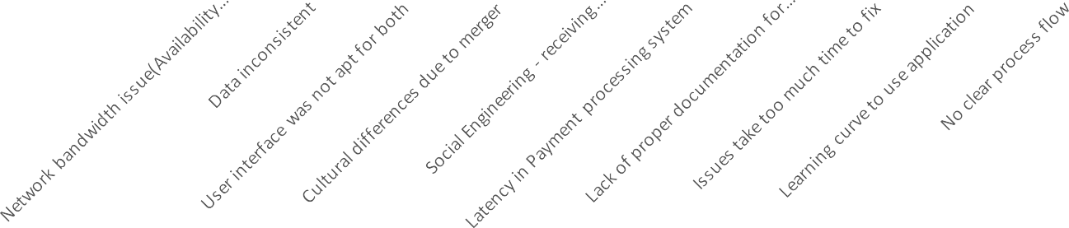

Pareto Chart

350

300

250

200

150

120.00%

100.00%

80.00%

60.00%

100

50

0

40.00%

20.00%

0.00%

Frequency

Cumulative Percentage



Scatter Chart

350

120.00%

300

100.00%

250

80.00%

200

60.00%

150

40.00%

100

50

20.00%

0

0.00%

Cumulative Percentage

Frequency